**Project Initialization and Planning Phase**

| Date | 14th July 2024 |
| --- | --- |
| Team ID | 739918 |
| Project Name | Food Demand Forecasting For Food Delivery Company |
| Maximum Marks | 3 Marks |

**Define Problem Statements (Customer Problem Statement Template):**

Create a problem statement to understand your customer's point of view. The Customer Problem Statement template helps you focus on what matters to create experiences people will love. A well-articulated customer problem statement allows you and your team to find the ideal solution for your customers' challenges. Throughout the process, you’ll also be able to empathize with your customers, which helps you better understand how they perceive your product or service.

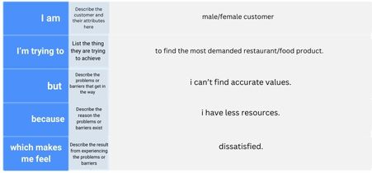

**Example:**

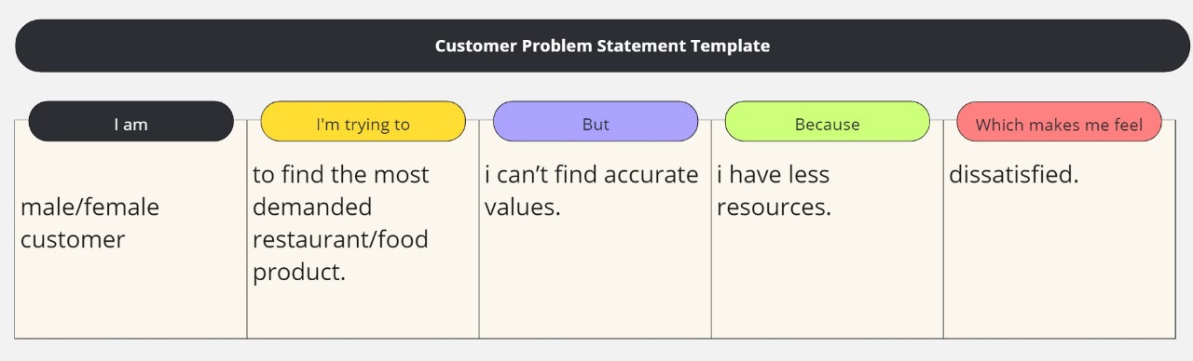

|  |  |  |  |  |  |
| --- | --- | --- | --- | --- | --- |
| **Problem**  **Statement (PS)** | **I am**  **(Customer)** | **I’m trying to** | **But** | **Because** | **Which makes me feel** |
| PS-1 | Male/female customer | Trying to find the most demanded restaurant/ food product | I cant find accurate values | I have less resources | dissatisfied |
| PS-2 | Male/female customer | Find the general review about a restaurant with the number of orders it is delivering in an area | I cant find the results | I have no probable values and records | dissatisfied |